JAR stands for java Archieve. We can define jar in multiple ways.

1. Jar is compressed file.
2. Jar is folder.

The jar is user for grouping multiple package as one unit and used for sharing all classes of project to client or to other developer via email.

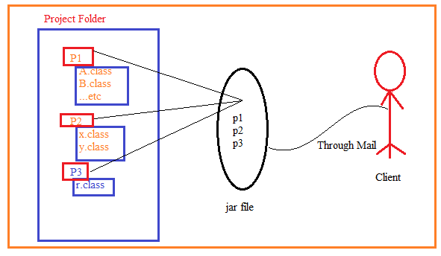

Diff between Jar and zip file

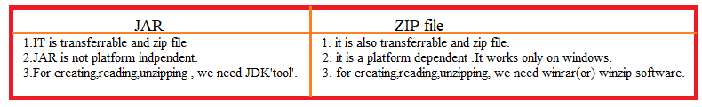

Syntax to create Jar File:

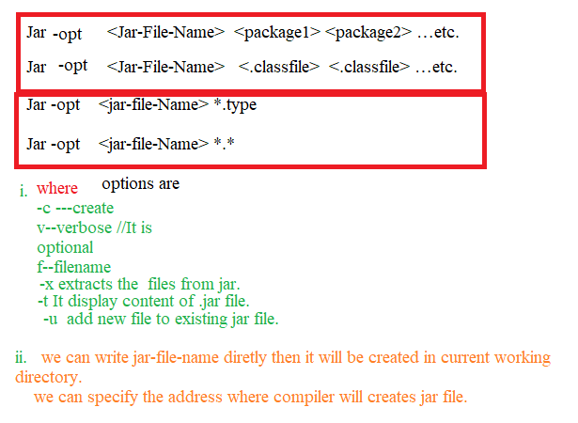

Example:1 Create abc.jar file with only .class file and place abc.jar in PWD.

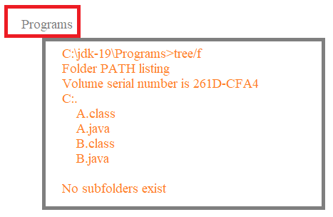

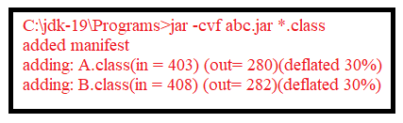

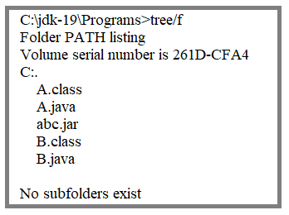

Example:2 Display the content of abc.jar

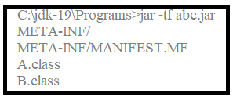

Example:3 Add all .java file to abc.jar and display the content of abc.jar.

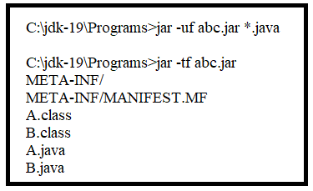

Example:4 Extract abc.jar file in PWD.

Step1: It is optional step. Remove all files unless abc.jar from PWD.

Step2: Extract abc.jar file.

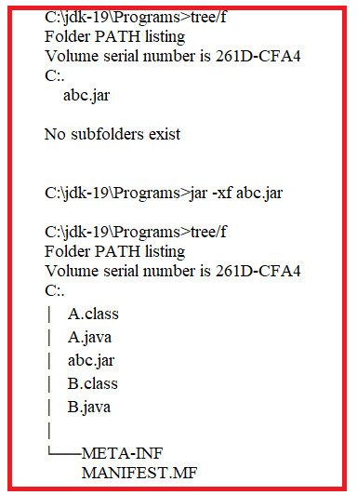

Example:5

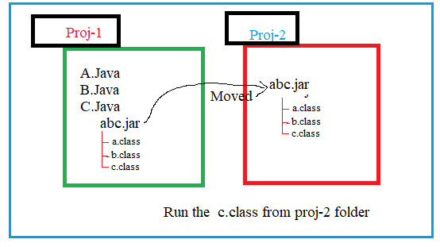

1.A.java

class A

{

public static void m1()

{

System.out.println("A-m1");

}

}

2.B.java

class B

{

public static void m2()

{

System.out.println("B-m2");

}

}

3.C.java

class C

{

public static void main(String[] args)

{

System.out.println("This is Main class");

A.m1();

B.m1();

}

}

Tree Structure

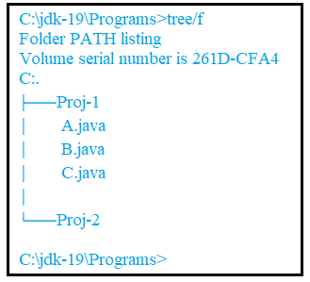

Step1: compile the C.java



Step2: Display tree , after compilation of c.java

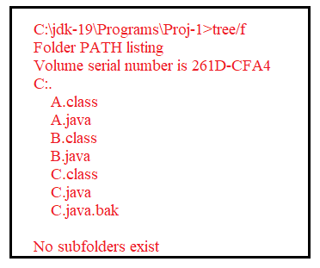

Step3: create abc.jar file.

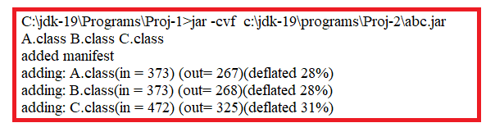

Step4: display tree, after creating the abc.jar file.

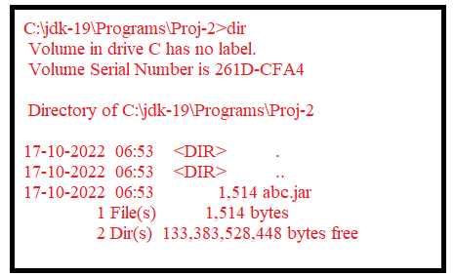

Step6: set Classpath .

C:\jdk-19\Programs\Proj-2>set classpath=%classpath%;.;abc.jar;

Step7: Run the ‘c.class’ from proj-2 folder.

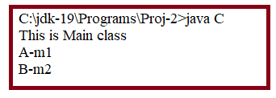

Example:2

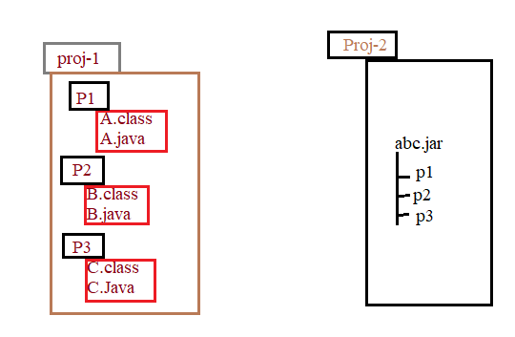

1.A.Java

package P1;

public class A

{

public static void m1()

{

System.out.println("A-m1");

}

}

2.B.Java

package P2;

import P1.A;

public class B

{

public static void m2()

{

System.out.println("B-m2");

}

}

3.C.Java

package p3;

import P1.A;

import P2.B;

public class C

{

public static void main(String[] args)

{

System.out.println("Main");

A.m1();

B.m2();

}

}

Step1: compile the C.java file from Proj-1 folder.

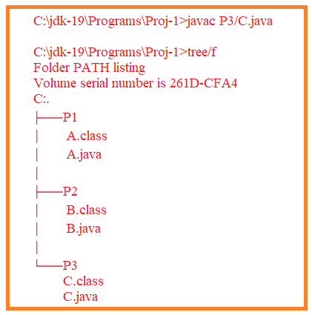

Step2: create abc.jar file in ‘proj-2’ folder.

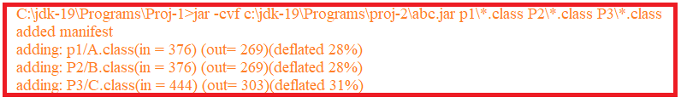

Step3: Display ‘proj-2’ folder structure.

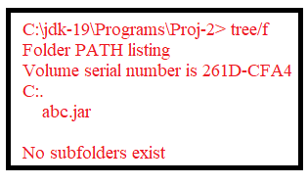

Step 4. Set classpath.